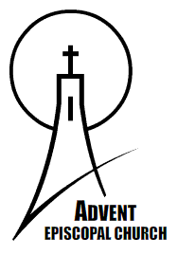
ADVENT EPISCOPAL CHURCH
www.adventepiscopal.org
Rector：The Rev. Dr. Chang, Yuan-Rung
499, Tam King Road, Sec. 4, Tamsui, Taipei 25135 Taiwan E-mail: iechang@mail.sju.edu.tw
Tel：886-2-28013131 Ext.6330,6331,6334 Fax：886-2-28013424

One Nine-Hundredth

I hope you are moved by what has moved her...
One day this last March, one of our parishioners came to me and said: “Pastor Chang, I am a housewife with no income, but I want to make an offering to our church. I have sold all my gold jewelry which was given to me by my husband at our wedding and I have divided the money into three parts, to donate to three different churches for their building funds. This is one of them. My husband fully supports me in this decision. As my husband gives his love to me, so I am willing to give this offering to the Lord. Although it is not a huge amount, with God’s blessing, great things can be accomplished. May many people benefit from this new Church Center.”

How gratified I felt when I received the offering from her! In relative terms this offering is tiny, only NT$ 20,000, and only accounts for one nine-hundredth of the construction budget for the new church center. But this offering is precious. It reminds us that Jesus praised the woman who offered her only two coins to the Lord. Hence, I pray to the Lord: “May God raise up 900 people to do as this generous parishioner has done!”

May you become one of these nine hundred people! And may you invite others to become a part of these nine hundred!

The land God has given to us
Advent Church is also called ‘The Rt. Rev. James C. L. Wang Memorial Church’, and has been serving the local community for more than 36 years since it opened on February 17, 1973. Over the years the needs of the church, university and local community have grown and changed. Our meeting rooms and facilities at Advent Church are now way too small and inadequate for our growing congregation and outreach programs. In response, we plan to construct a new building named the ‘Bishop James Wang Church Center’ to facilitate the church with our educational, training, counseling, social, community and evangelistic ministries.

We only need 900 people to play their part as the one nine-hundredth! With these 900 people, we can accomplish a great marvel—this building will be the center for spiritual growth of the faculty, staff and students of St. John’s University; a base for the student chaplaincy ministry, a caring place where a cup of tea is provided for the residents from the local community; a restful place where alumni can visit; a learning place for school children to enjoy their after-school activities; an exciting place for children and young people who come for Sunday school classes, English Bible classes, music band and youth group; a relaxing place for the church members to have lunch after the Sunday services and a place to share their spiritual lives.

The area of the new Bishop James Wang Church Center will be 6480 square feet, with one ground level and one basement level. It will be built in an environmentally- friendly and energy-saving way, with a roof of grass and multi-level planting. The four Stations of the Cross presently on the site will be also incorporated into the overall design.

Bishop James Wang’s prayer
When Bishop James Wang was in hospital nearing the end of his life; from March 29 to April 27, 1970 he wrote this prayer: My life is nearing its end. In this life, I have found what I wanted to learn, what I wanted to love, and what I hoped for; in my ministry, I have already been rewarded with what I deserved. This life is going to end according to God’s natural law unknown to men. If there is another world waiting for me, I definitely will use the experiences I gained in this world to continue my work!

I pray for God’s mercy to hear our prayers. Let us continue Bishop Wang’s responsibilities to St. John’s University and the church’s mission to the community.
I look forward to starting the construction of the Bishop James Wang Church Center on April 27, 2010, the 40th anniversary of Bishop James Wang’s death; and I hope to complete the construction and open its doors by the end of 2010.

The total cost of the project is NT$18,000,000, which we hope will be raised from church members, friends and alumni, and faculty and staff of St. John’s University. Please join us!

Rector：The Rev. Dr. Chang, Yuan-Rung

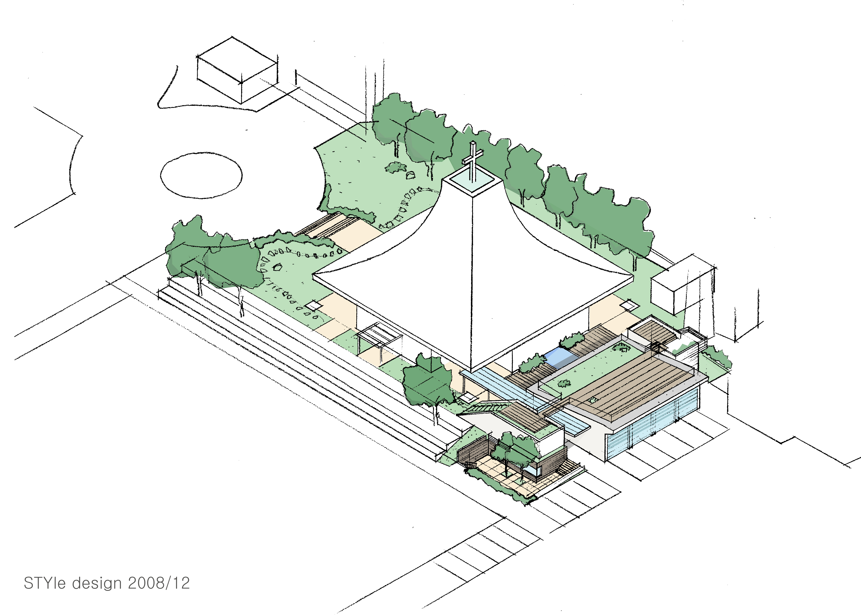

Bishop James Wang Church Center

